Task 1, Linux 42Q

- Create user with name Techie and provide sudo access to user.
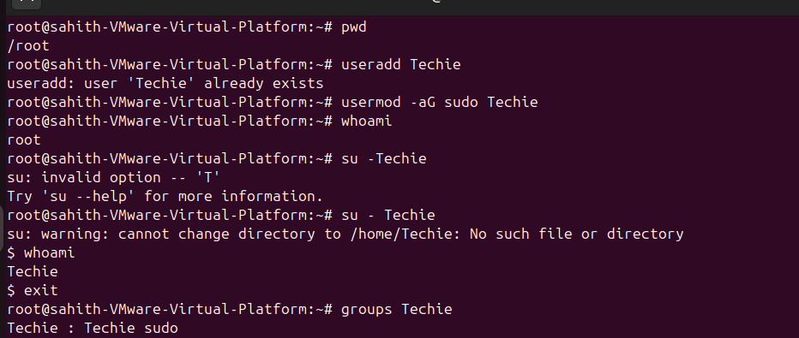
- Navigate to the home directory.
- Create a new directory.
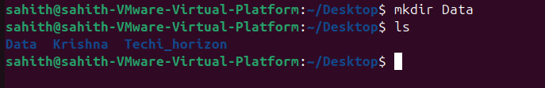
- List the contents of a directory.
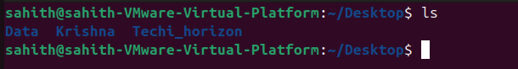
- Change the current directory.
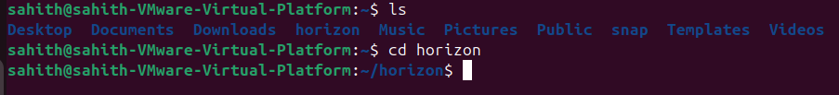
- Create a new empty file.
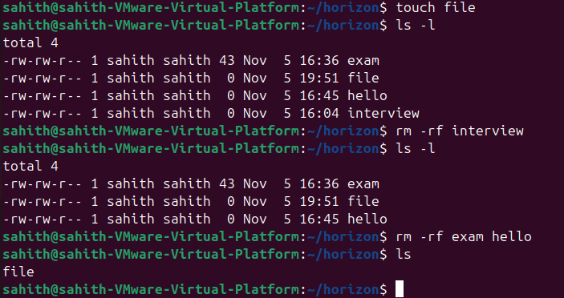
- View the contents of a file.
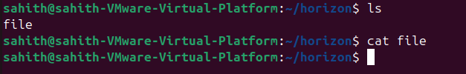
- Copy a file to another location.
- Move a file to another location.
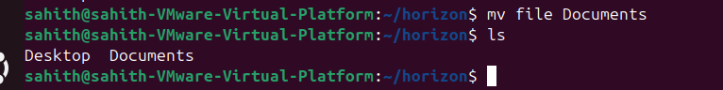
- Rename a file.
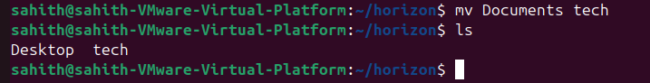
- Delete a file.
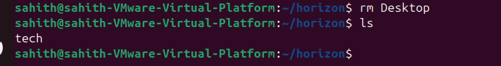
- Grant or revoke permissions on a file or directory.
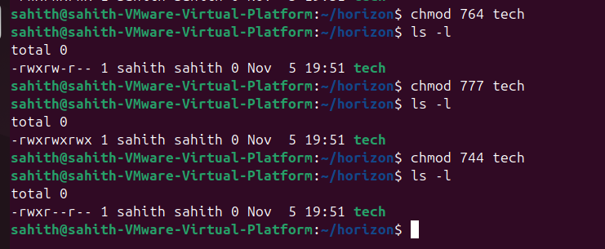
- View the current date and time.
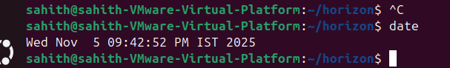
- Check the system uptime.
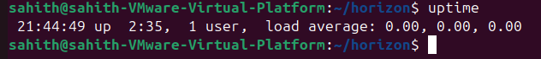
- View the running processes.
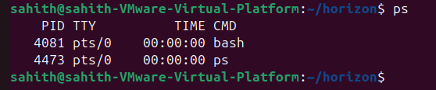
- Kill a running process.
Opened firefor and used pkill firefox
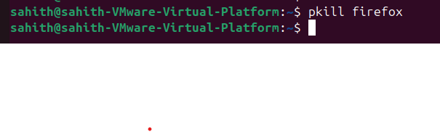
- Install a package using the package manager (e.g., apt or yum).
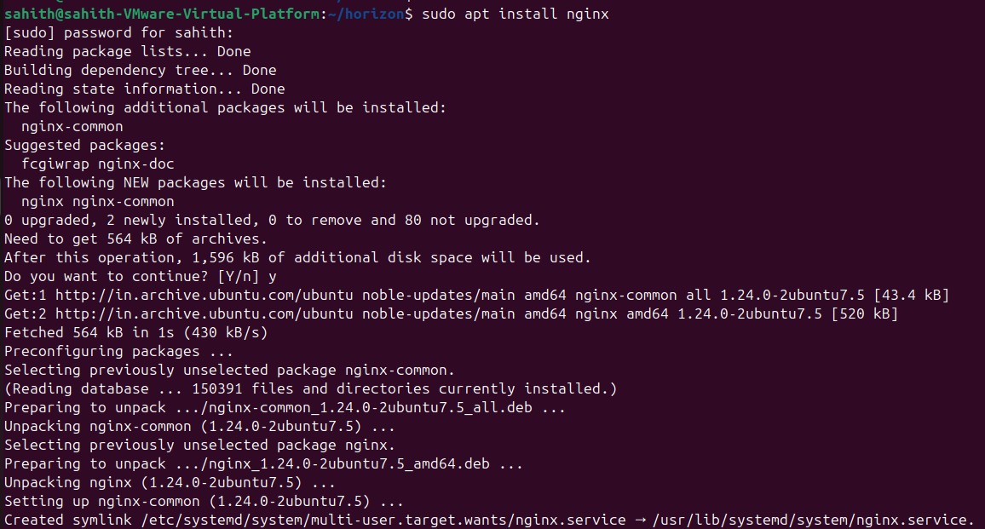
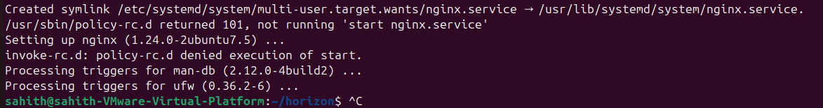
- Update the system packages.
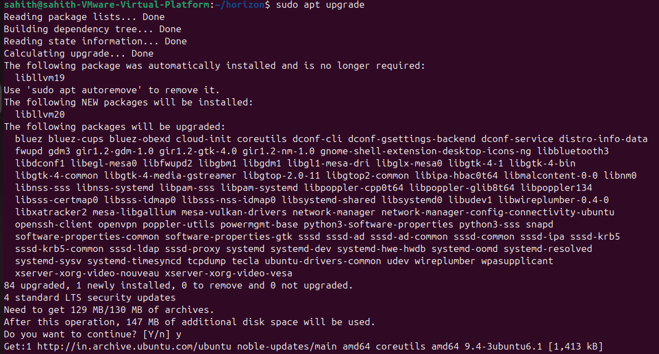
- 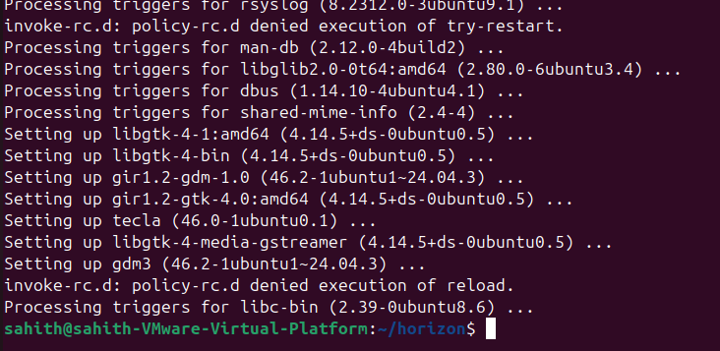
- Create a symbolic link.
- Search for files using the find command.
- Compress and decompress files using tar.
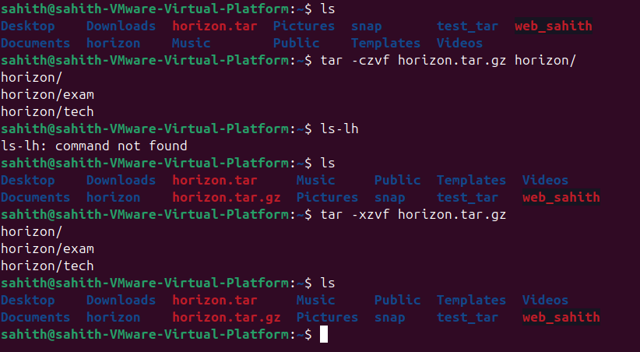
- Monitor system resources with top or htop.
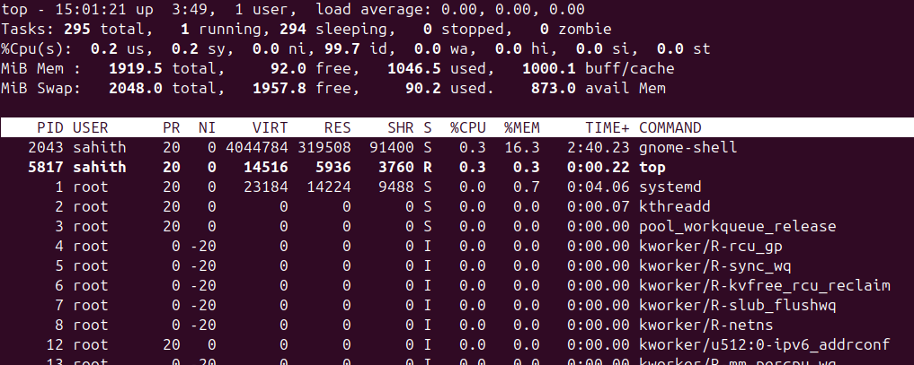
- Create and manage user groups.
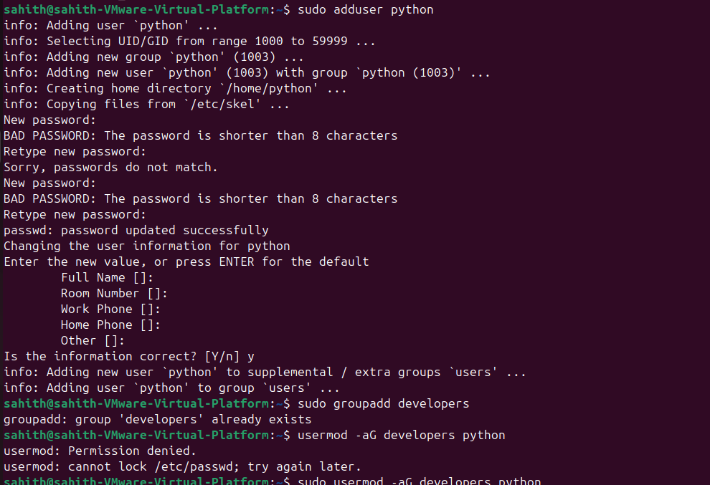
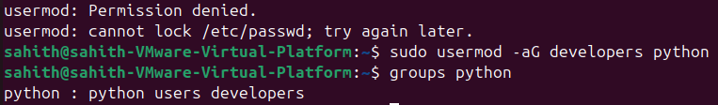
- Set up SSH password less authentication.
- Monitor log files using tail or grep.
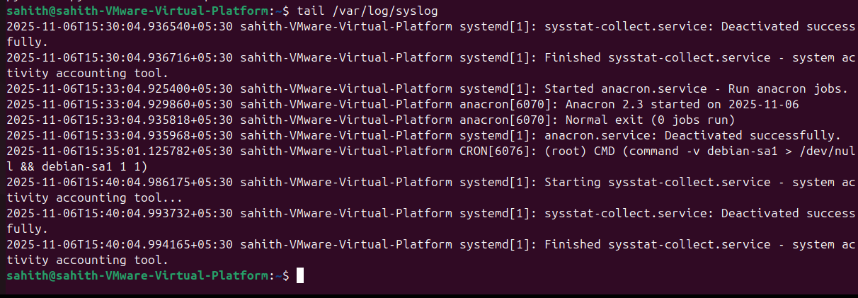

- Set up a web server (e.g., Apache or Nginx).
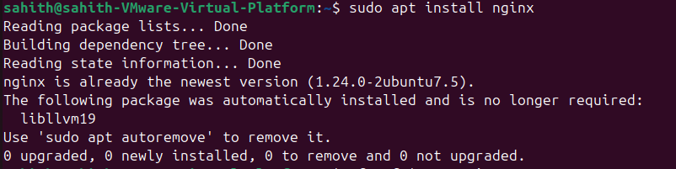
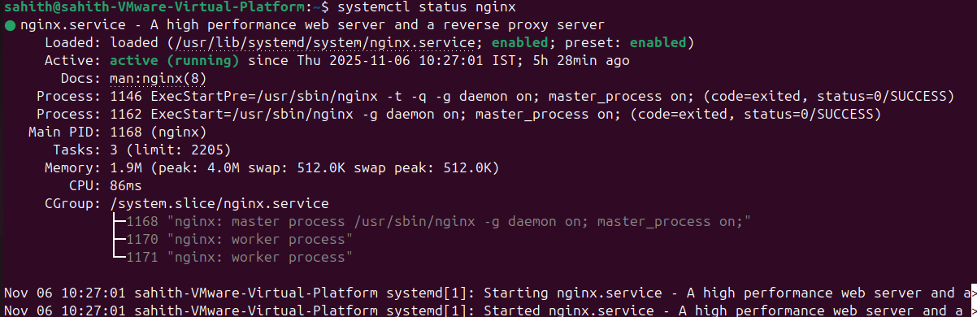
- Configure and secure a MySQL Database.
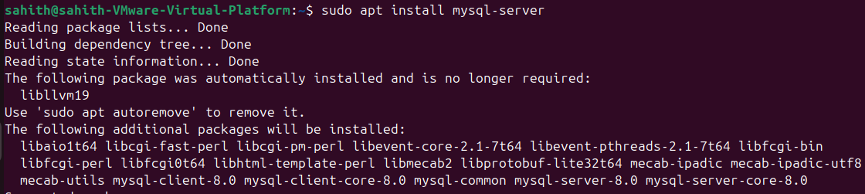
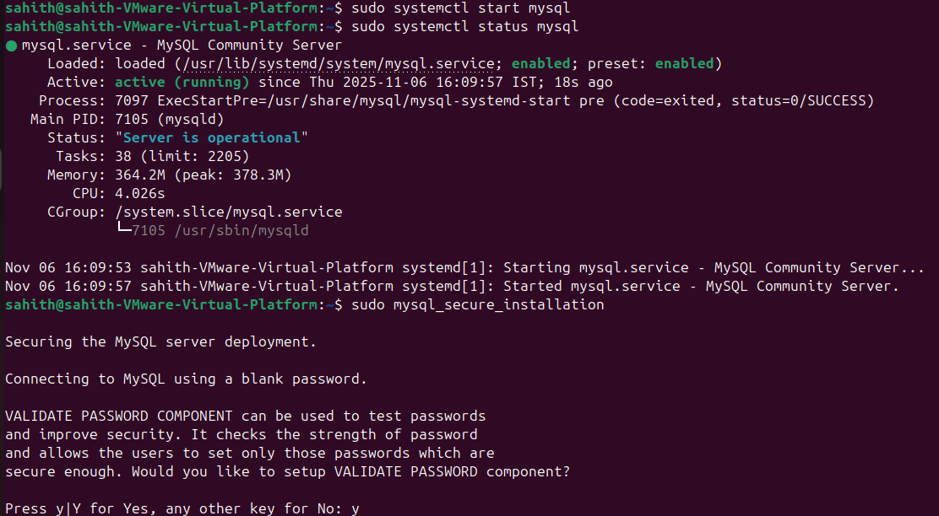
- Set up a Application Server (e.g.,Apache Tomcat)
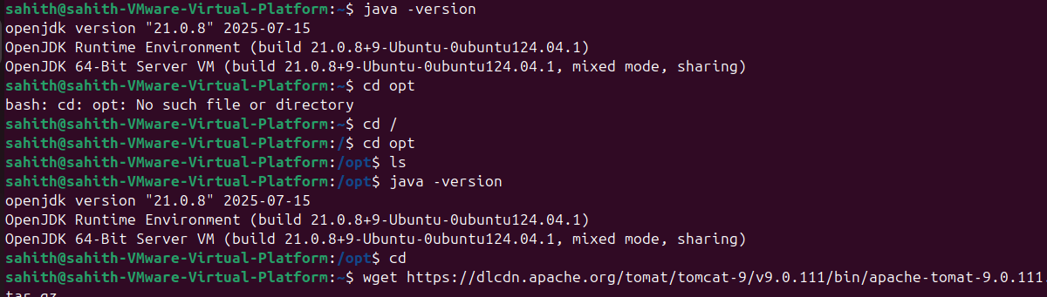
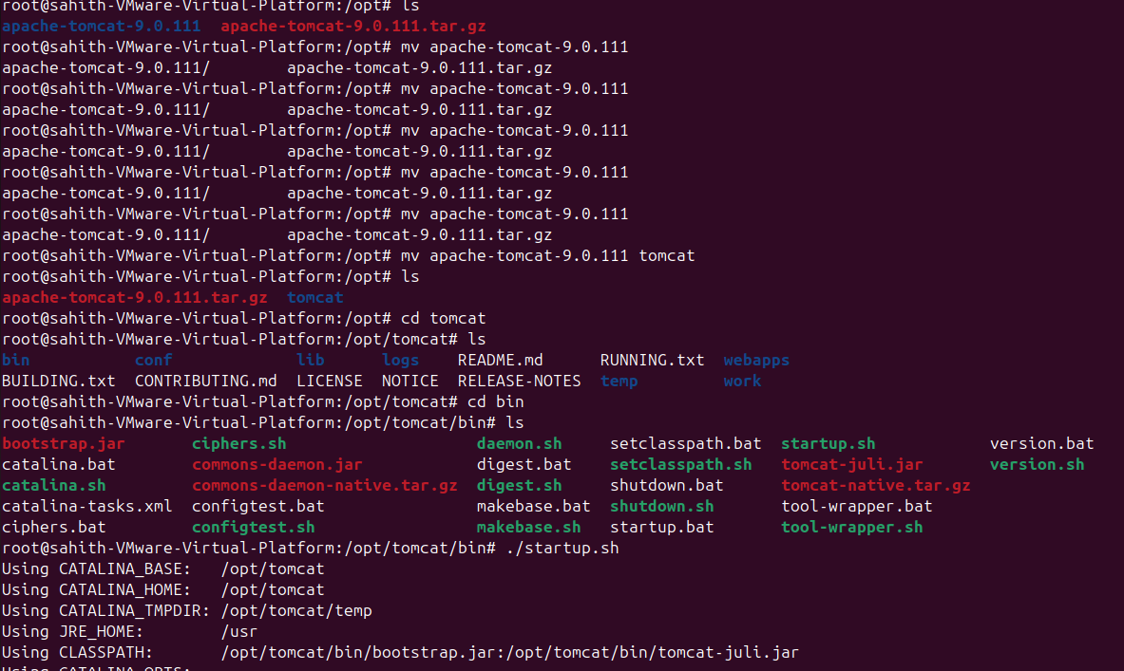
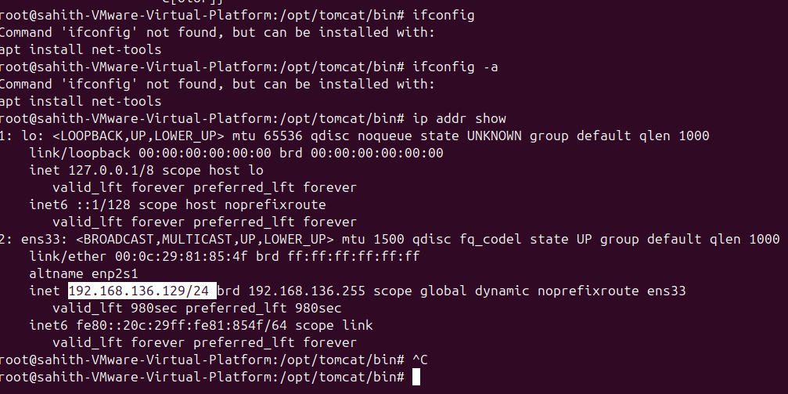
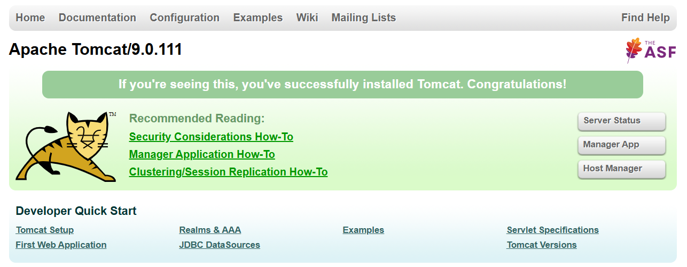

- create a service file for Apache Tomcat.(Should execute by using systemtctl command)
- Print specific columns from a delimited file.
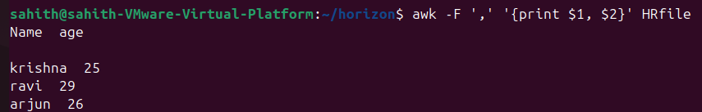
- Filter and print lines based on a specific pattern or condition.
- Calculate and print the average, sum, or other statistics of a column.
- Perform string manipulation, such as extracting substrings or changing case.
- Count the occurrences of a specific pattern in a file.
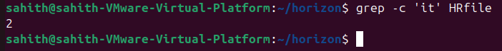
- Sort lines based on a specific field or column.
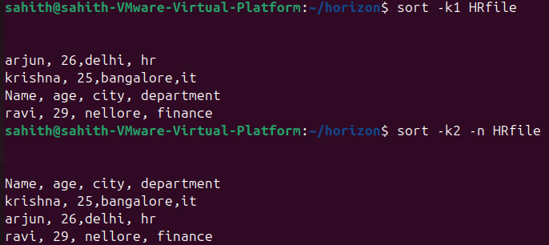
- Merge multiple files based on a common field or column.
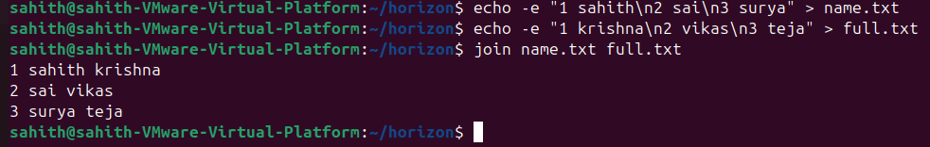
- Substitute text in a file using search and replace.
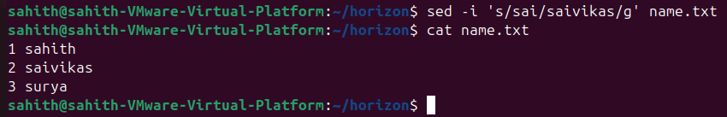
- Delete specific lines based on a pattern or line number.
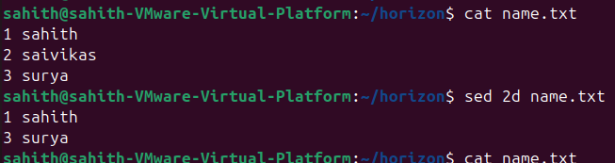
- Append or insert text before or after a specific pattern or line.
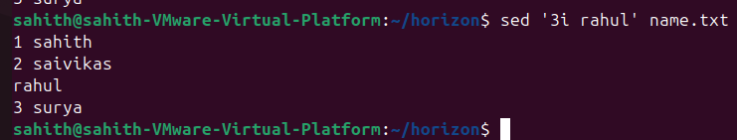
- Print only specific lines from a file.
